[**SRTechOps**](https://www.youtube.com/@srtechops)

[**https://github.com/torvalds/linux/graphs/contributors**](https://github.com/torvalds/linux/graphs/contributors)

MobaXterm is an advanced terminal emulator and remote desktop application for Windows. It provides a powerful, all-in-one solution for developers, system administrators, and IT professionals who need to manage remote systems.

**Key Features of MobaXterm:**

1. **Built-in X Server** – Supports X11 forwarding, allowing you to run Linux GUI applications on Windows.
2. **Multiple Network Tools** – Includes SSH, SCP, SFTP, FTP, RDP, VNC, and Telnet for remote access.
3. **Tabbed Terminal with Unix Commands** – Comes with a portable bash shell and Unix commands (like ls, grep, sed, awk, etc.).
4. **Session Management** – Allows saving and managing multiple remote connections efficiently.
5. **SSH Tunneling and Port Forwarding** – Helps secure connections to remote systems.
6. **Macros and Automation** – Supports scripting to automate tasks.
7. **Plugins and Extensions** – Expand functionality with additional tools like Python, Git, and more.
8. **Portable Version** – Can be used without installation.

MobaXterm is particularly useful for those who work with remote Linux servers from a Windows environment, making remote management and development much easier.

**Day 2 - What is an OS? How It Works & Why Linux is the Best | Linux vs Windows Explained**

<https://www.youtube.com/watch?v=gRtQOa1l3Vc&list=PL7iDpp0KYTgFhKnHr7X78A8hWFaqOzN6W>

An Operating System (OS) is the backbone of any computer, managing hardware, software, and user interactions. But how does it work, and why do many tech professionals prefer Linux over Windows? Let’s break it down in this beginner-friendly tutorial!

📌 **What You Will Learn:**

✅ What is an Operating System? – Understand the core functions and importance of an OS.

✅ How an OS Works – Learn about process management, memory management, file systems, and security.

✅ Types of Operating Systems – Explore different types like Windows, macOS, Linux, and Unix.

✅ Linux vs Windows – Compare key aspects like performance, security, flexibility, and cost-effectiveness.

✅ Why Linux is the Best Choice? – Discover why developers, system admins, and DevOps professionals prefer Linux.

✅ Getting Started with Linux – Learn how to choose a Linux distribution and install it on your system.

**Day 3 - Essential Linux Commands | You Should Know**

<https://www.youtube.com/watch?v=kP7V_gJT560&list=PL7iDpp0KYTgFhKnHr7X78A8hWFaqOzN6W&index=2>

Linux is a powerful operating system, and mastering essential commands is crucial for developers, system administrators, and DevOps engineers. In this tutorial, we’ll cover the most important Linux commands you need to know for file management, process control, user management, networking, and more!

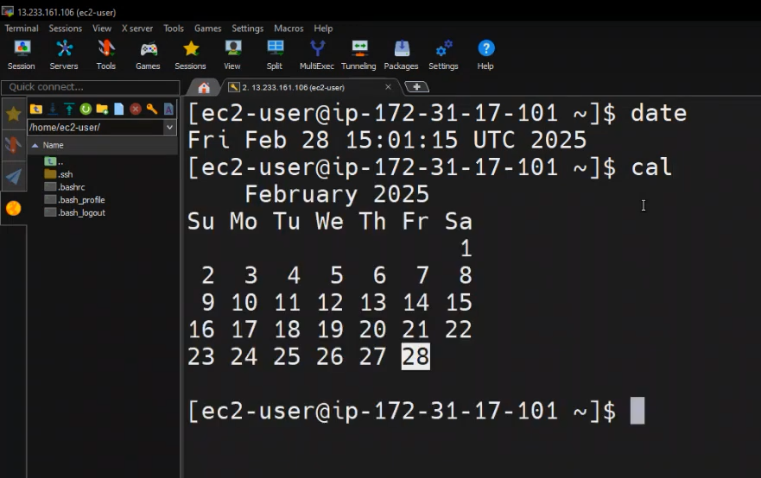

**Linux Commands:**

>date

>cal

> mkdir sample

> ls

>rmdir sample // It will delete only empty directory

> rm -rf sample // Even the directory contains files or directories, It will be deleted. rf means recureerce force.

> mkdir devops cloud design develop

>rmdir *

> cat sample.txt // To view content

> cat > my.txt // create and add content, If the file is already created, new content will be replaced with the older content.

> cat >> my.txt // append content without impacting existing content.

> mv one.txt two.txt // rename the file or directory

>mv two.txt devops // move the file/directory one to another place

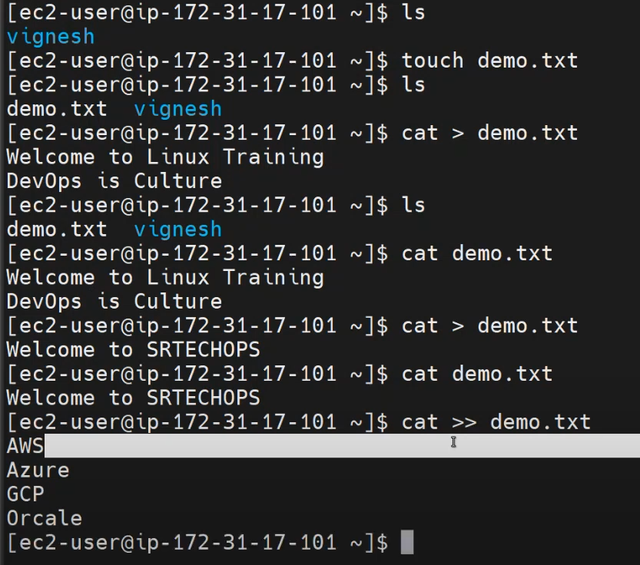

We can’t make any text edit using “**cat**”. So that case, we go with “**nano**”

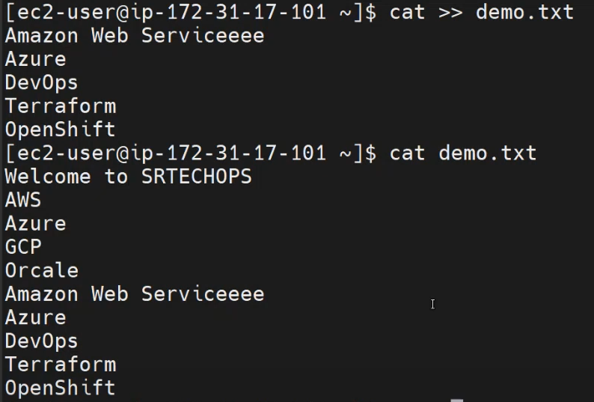

**>vi demo.txt // When we use vi, pressing “i” key go to insert mode, make content , then press “esc” key and press :w to save and :q to quit and :wq or :wq! To save and quit.**

One

Two

Three

:w // Save

:q // Quit

:wq! Or :wq // Save & Quit

**Day 4 - Essential Linux Commands | You Should Know**

**Linux is a powerful operating system, and mastering essential commands is crucial for developers, system administrators, and DevOps engineers. In this tutorial, we’ll cover the most important Linux commands you need to know for file management, process control, user management, networking, and more!**

<https://www.youtube.com/watch?v=Wfi_SnkdWlw&list=PL7iDpp0KYTgFhKnHr7X78A8hWFaqOzN6W&index=3>

>ls

> ls -l

>ls -lt // list based on time

> ls -lr // list reverse order

> ls -ltr // list based on time reverse order

> ls -a

>ls -lS // sort by size

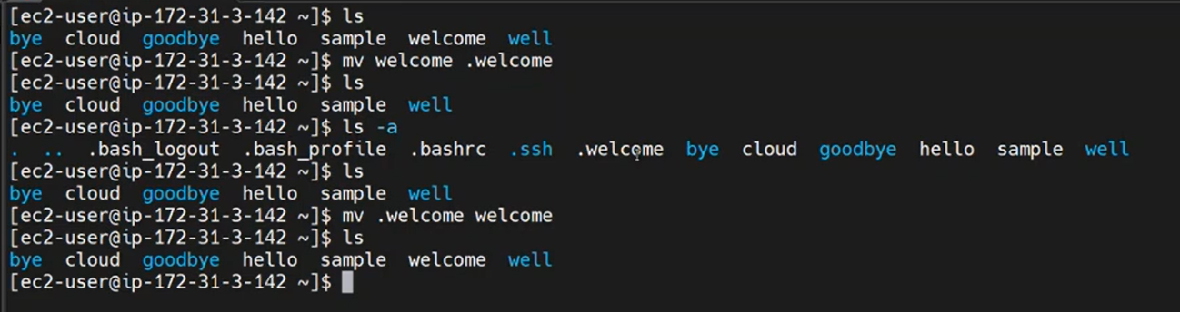

If you want to hidden a file use “.” in front of the file refer below using mv:

>mv my.txt .my.txt

> history // to view all executed commands

> history -c // To clear all history commands

> history -d 4 // To delete particular command line ie 4th command on the history

> history -d 2 3 5 // To delete 2, 3, 5 command line on the history

> man ls // Manual documentation/details about ls command

> pwd // present working directory

> cd devops // change directory OR switch one directory to another

> cd .. // one step backward

> cd ~ // Move to home directory

> clear or ctrl+l

**Day 5 - Essential Linux Commands | You Should Know**

Linux is a powerful operating system, and mastering essential commands is crucial for developers, system administrators, and DevOps engineers. In this tutorial, we’ll cover the most important Linux commands you need to know for file management, process control, user management, networking, and more!

<https://www.youtube.com/watch?v=3x6trNO8KZM&list=PL7iDpp0KYTgFhKnHr7X78A8hWFaqOzN6W&index=4>

>mv one.txt two.txt // rename the file/directory

>mv two.txt devlops // move the file/directory

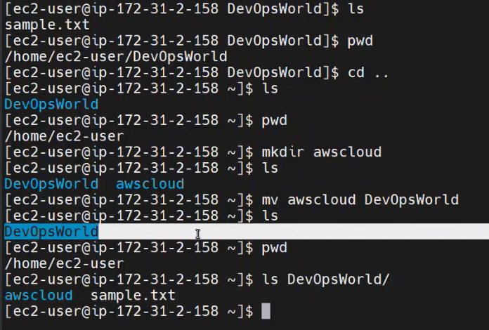

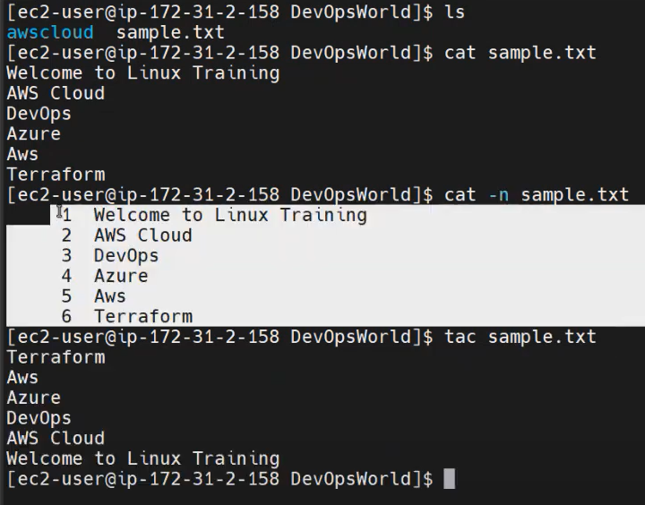

**>cp sample.txt hello.txt // this mean, content of the sample.txt will be copied and paste it to hello.txt. If the hello.txt file is not available, then it will create and paste content.**

**>cp sample.txt cloud/ // this mean, content of the sample.txt will be copied and file name is mentioned on the cloud folder. That case, it will create a same file and paste it.**

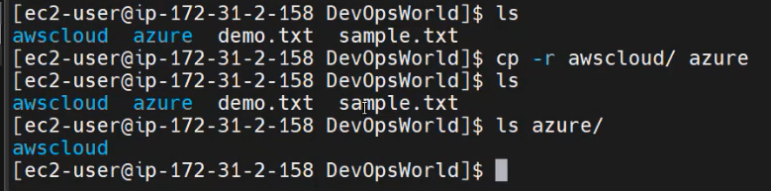

**If you want to copy the directory use**

**>cp -r myfolder yourfolder/ // -r means recurresive**

**Head & Tail Command: //** It useful while analysis the log file.

>head sample.txt // Will display first 10 lines

>head -n 5 sample.txt // will display first 5 lines

>tail sample.txt // Will display last 10 lines

>tail -n 5 sample.txt // Will display last 5 lines

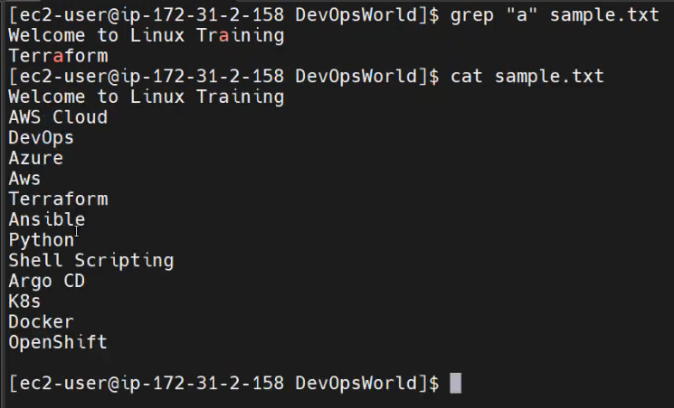

**grep:**

**grep Command in Linux**

The grep (**Global Regular Expression Print**) command is used for searching text patterns in files or output streams. It scans a file line by line, looking for a specified pattern and prints the matching lines.

**Basic Syntax:**

bash

CopyEdit

grep [OPTIONS] PATTERN [FILE...]

* **PATTERN** – The text or regular expression to search for.
* **FILE** – The file(s) to search in.
* **OPTIONS** – Flags to modify the behavior of grep.

**Commonly Used grep Options:**

| **Option** | **Description** |
| --- | --- |
| -i | Ignore case (case-insensitive search) |
| -v | Invert match (show lines that **do not** match the pattern) |
| -c | Count the number of matching lines |
| -n | Show line numbers along with matching lines |
| -l | List only filenames with matching lines |
| -w | Match whole words only |
| -r | Recursively search directories |
| -E | Use extended regular expressions (like egrep) |

**Examples of grep Usage:**

**1. Basic Text Search**

grep "error" logfile.txt

Searches for the word "error" in logfile.txt and prints matching lines.

**2. Case-Insensitive Search**

grep -i "hello" file.txt

Finds "hello", "HELLO", "Hello", etc.

**3. Search in Multiple Files**

grep "warning" *.log

Searches for "warning" in all .log files.

**4. Show Line Numbers**

grep -n "failed" system.log

Prints matching lines along with their line numbers.

**5. Count Matches**

grep -c "success" output.txt

Counts the number of lines containing "success".

**6. Show Only Filenames with Matches**

grep -l "error" *.txt

Displays only the filenames that contain "error".

**7. Exclude Matching Lines (-v)**

grep -v "debug" app.log

Displays lines **without** "debug".

**8. Recursive Search in a Directory**

grep -r "database" /var/logs/

Searches "database" in all files under /var/logs/.

**9. Matching Whole Words (-w)**

grep -w "root" /etc/passwd

Matches only "root" and not "rootuser".

**10. Using Regular Expressions**

grep -E "error|warning|failed" log.txt

Finds "error", "warning", or "failed" in log.txt.

**Combining grep with Other Commands**

* **Filter output of ls**

ls -l | grep "Jan"

Lists only files modified in January.

* **Find Running Processes**

ps aux | grep "apache"

Shows processes related to apache.

* **Search Inside a tar.gz File**

zgrep "pattern" archive.tar.gz

Searches inside a compressed file.

**Conclusion**

The grep command is a powerful tool for searching and filtering text. Its combination with other Linux commands makes it an essential skill for system administrators, developers, and DevOps engineers.

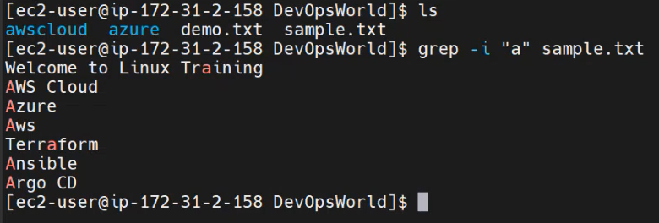

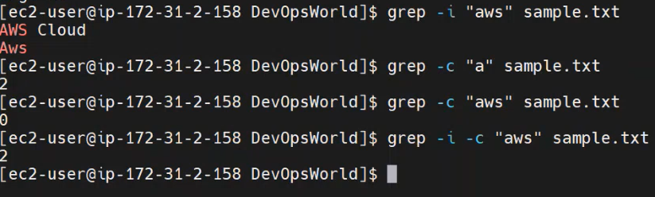

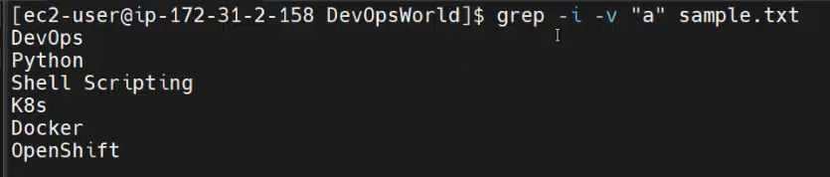

**If you want to pass a command output as a input of another command use | (Pipe) symbol:**





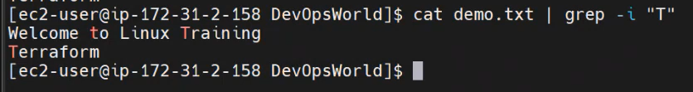

>wc command used to fine number of lines, words, characters on the file.

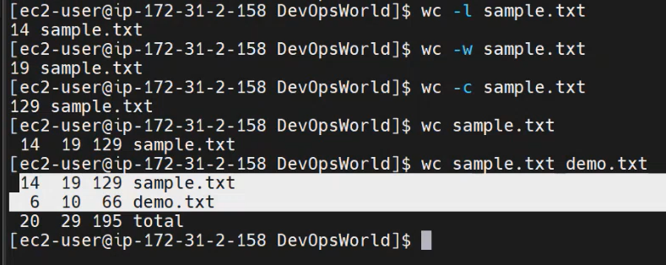

**Day 6 - Essential Linux Commands | You Should Know**

Linux is a powerful operating system, and mastering essential commands is crucial for developers, system administrators, and DevOps engineers. In this tutorial, we’ll cover the most important Linux commands you need to know for file management, process control, user management, networking, and more!

<https://www.youtube.com/watch?v=okkMb9lzoKU&list=PL7iDpp0KYTgFhKnHr7X78A8hWFaqOzN6W&index=5&t=3s>

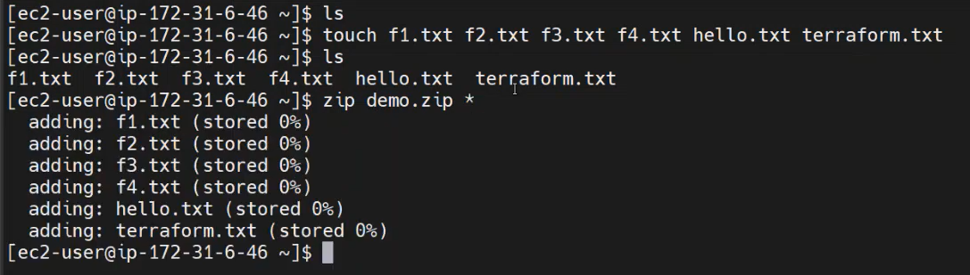

>zip demo.zip *

>zip -sf demo.zip // -sf > show files

>zip demo.zip newfile.txt or zip demo.zip *.txt// Adding new file to the zip folder

>zip -d demo.zip newfile.txt // Deleting new file to the zip folder

>zip -sf demo.zip

>unzip demo.zip

> zip -e demo.zip *.txt // e – Encryption

>zip -e new.zip old.zip

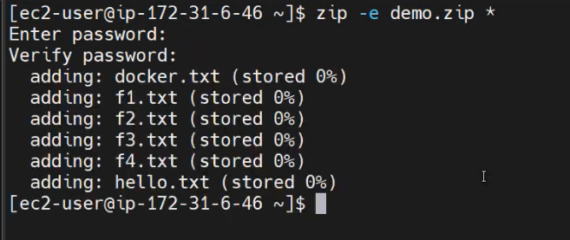

>rm *.txt

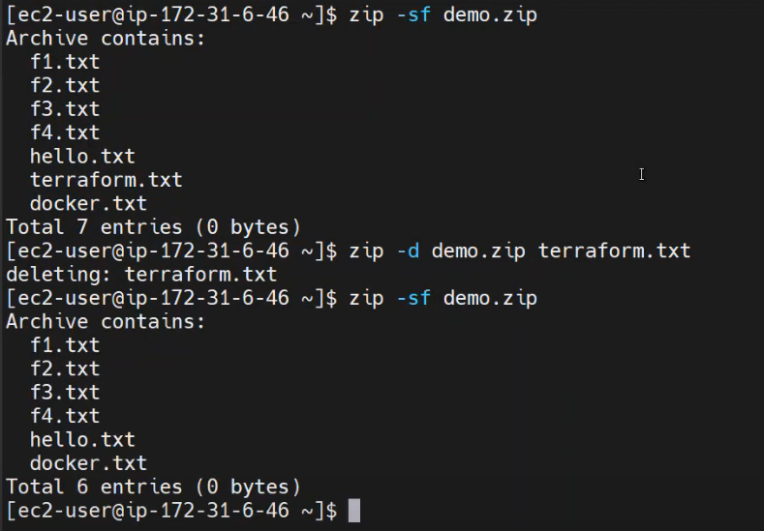

Normal User:

[ec2-user@ip-172-31-27-212 ~]**$**

Change normal user to Root user:

>sudo su // Super User Do Switch User

Admin / Root User:

[root@ip-172-31-27-212 ec2-user]**#**

Admin to Normal User:

>exit

**User Management:**

New user creation with password:

>useradd anbu

>passwd anbu

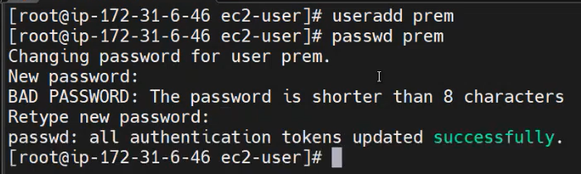

Check the user creation:

>cat /etc/passwd

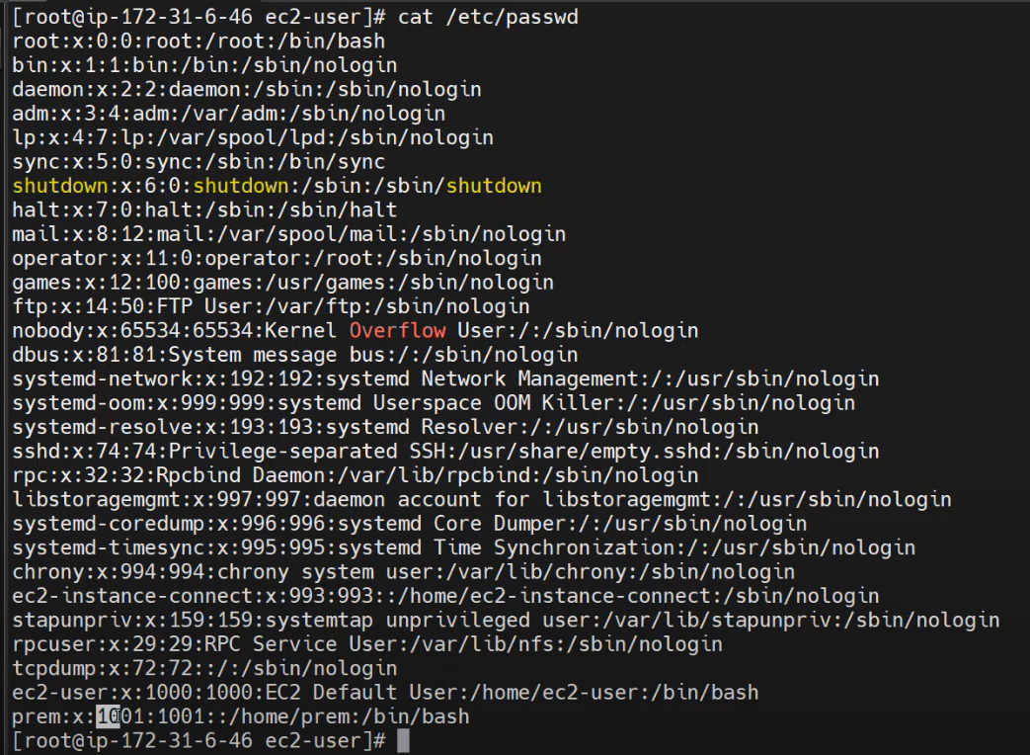

Switch to the particular user:

>su anbu  
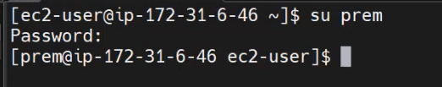

When we create a user, the below 3 things will happen:

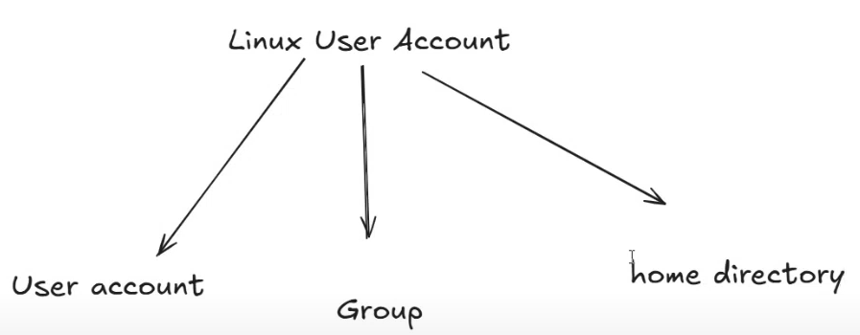

root>cat /etc/passwd

root>cat /etc/group

root> cd home

roo/home> ls

ec2-user anbu

**root>usermod -l raja raju // Change/modify username // -l > new login**



root> mv raju/ raja/

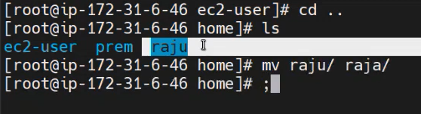

root>groupmod -n raja raju // Change/modify group // -n > new name

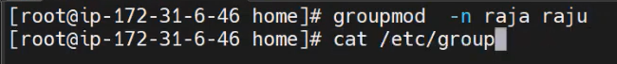

root>userdel raja

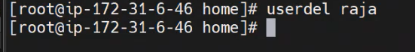

When we delete the user, the directory will not delete. Need to delete separately.

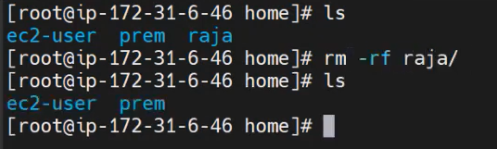

If you want to remove the user with directory, use below:

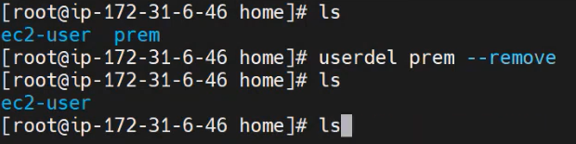

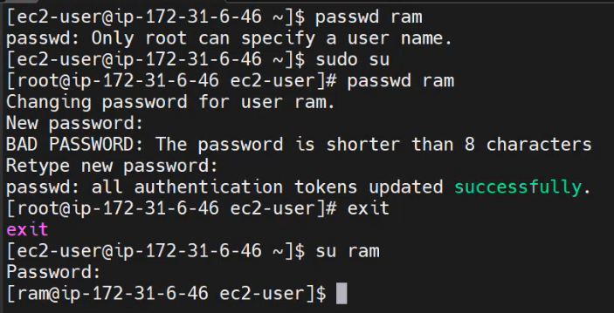

**Day 7 - Linux Group Management & File Permissions Explained | User, Group, chmod**

<https://www.youtube.com/watch?v=Nt7AoYSL4cs&list=PL7iDpp0KYTgFhKnHr7X78A8hWFaqOzN6W&index=6>

**Group Management:**

>groupadd DevTeam

>cat /etc/group

>lid -g DevTeam // To view list of user on the DevTeam Group

**2 Way to add user to the Group:**

1:

>gpasswd -a ec2-user DevTeam // Add user to DevTeam group

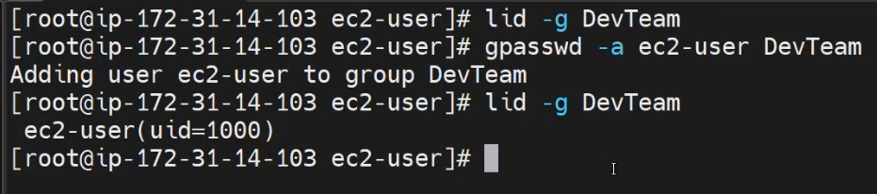

2:

>usermod -aG DevTeam inbha

>lid -g DevTeam

Deleting user from the Group:

root>gpasswd -d anbu DevTeam

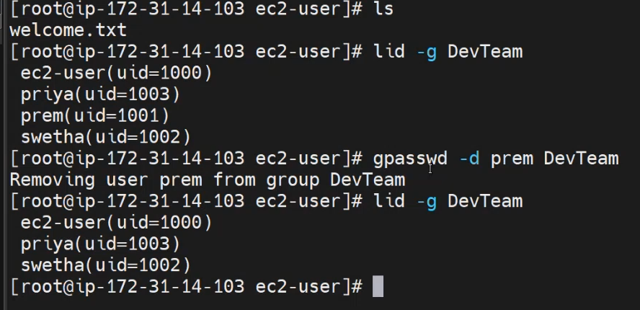

Renaming the Group:



Deleting the Group:



**\*\*\*\*\*\*\*\*\*\*\*File Permission:\*\*\*\*\*\*\*\*\*\*\*\*\*\*\*\*\*\*\*\*\***

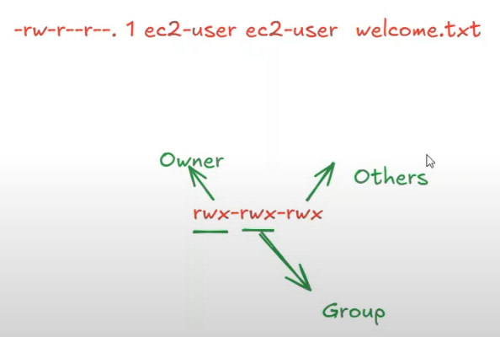

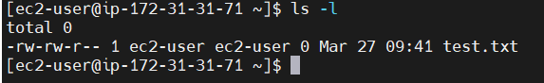

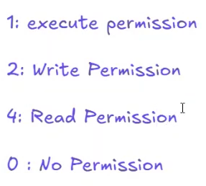

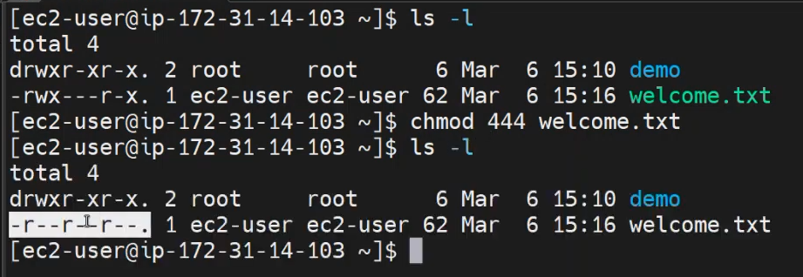

**Scenario:**

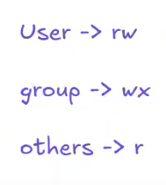

Answer:

>chmod 634 welcome.txt

The chmod command in Linux is used to **change file permissions** (read, write, and execute) for the owner, group, and others. It stands for **"change mode"**.

**Syntax:**

chmod [OPTIONS] MODE FILE

**Understanding File Permissions**

Each file in Linux has three permission types:

* **r (read)** → View file contents
* **w (write)** → Modify or delete file
* **x (execute)** → Run the file as a program

Each file is associated with three user categories:

1. **User (u)** → Owner of the file
2. **Group (g)** → Users in the file's group
3. **Others (o)** → Everyone else

**Ways to Change Permissions**

**1. Using Symbolic Mode**

Modify permissions with letters:

chmod u+r FILE # Give read permission to the owner

chmod g-w FILE # Remove write permission from the group

chmod o+x FILE # Give execute permission to others

chmod u=rwx,g=rx,o=r FILE # Set specific permissions

chmod a+x FILE # Give execute permission to all (a = u, g, o)

**2. Using Numeric (Octal) Mode**

Each permission has a numeric value:

* **r = 4**, **w = 2**, **x = 1**

Permissions are represented in 3-digit format:

* **Owner | Group | Others**

Example:

chmod 755 FILE

Breakdown:

* **7 (Owner) = r(4) + w(2) + x(1) = rwx**
* **5 (Group) = r(4) + x(1) = r-x**
* **5 (Others) = r(4) + x(1) = r-x**

Other common values:

* 777 → Full permissions for everyone (rwxrwxrwx)
* 644 → Read & write for owner, read-only for others (rw-r--r--)
* 600 → Only owner can read & write (rw-------)

**Recursive Permission Change**

To change permissions for all files in a directory:

chmod -R 755 DIRECTORY

**Common Use Cases**

* Make a script executable:

chmod +x script.sh

* Set permissions for a web server:

chmod 644 index.html

chmod 755 /var/www/html

Since file permissions are set for **Owner, Group, and Others**, the final permission mode is a **3-digit number** where:

* First digit → Owner
* Second digit → Group
* Third digit → Others

**Example Full Permissions Table**

| **Octal** | **Permission** | **Meaning** |
| --- | --- | --- |
| 000 | --------- | No one can access |
| 111 | --x--x--x | Execute only for all |
| 222 | -w--w--w- | Write only for all |
| 333 | -wx-wx-wx | Write & Execute for all |
| 444 | r--r--r-- | Read only for all |
| 555 | r-xr-xr-x | Read & Execute for all |
| 666 | rw-rw-rw- | Read & Write for all |
| 777 | rwxrwxrwx | Full access for all |

**Common Usage Examples**

* chmod 755 file → rwxr-xr-x (Owner: full, Group & Others: read & execute)
* chmod 644 file → rw-r--r-- (Owner: read & write, others: read only)
* chmod 700 file → rwx------ (Only the owner has full access)
* chmod 600 file → rw------- (Owner: read & write, no access for others)
* chmod 400 file → r-------- (Owner: read only, others have no access)

**Day 8 - Linux chown Command & Package Managers Explained | Change Ownership & Install Software**

<https://www.youtube.com/watch?v=6T_S_YH8Ku8&list=PL7iDpp0KYTgFhKnHr7X78A8hWFaqOzN6W&index=7>

**Ownership:**

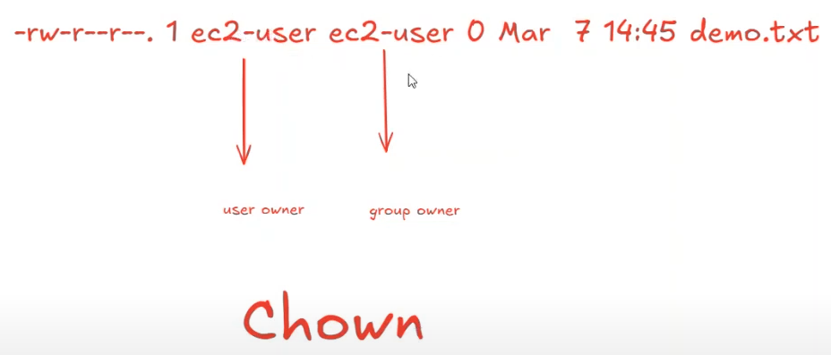

**If you add sudo in front of the command, It will run from ROOT user, No need to exit and switch user each time.**

**>sudo <command>**

How to change user owner & group owner:

>sudo chown anbu demo.txt

>sudo chown :DevTeam demo.txt

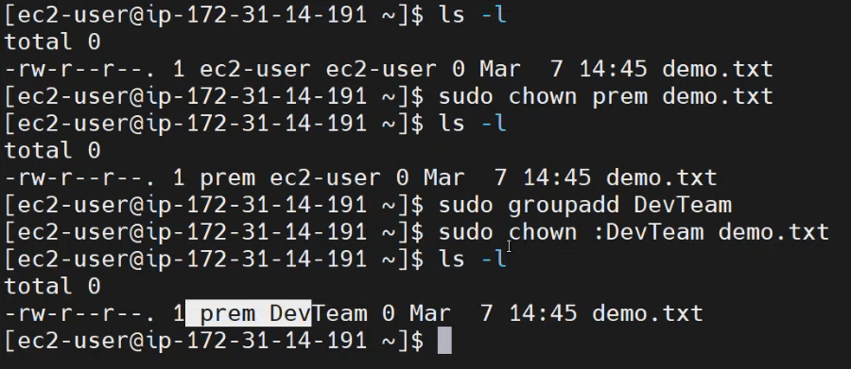

**How to change user owner and group owner in a single command:**

>sudo chown anbu :TestTeam demo.txt

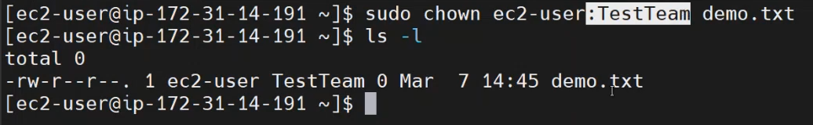

**Changing ownership for parent folder, will not applicable for sub folder and files.**

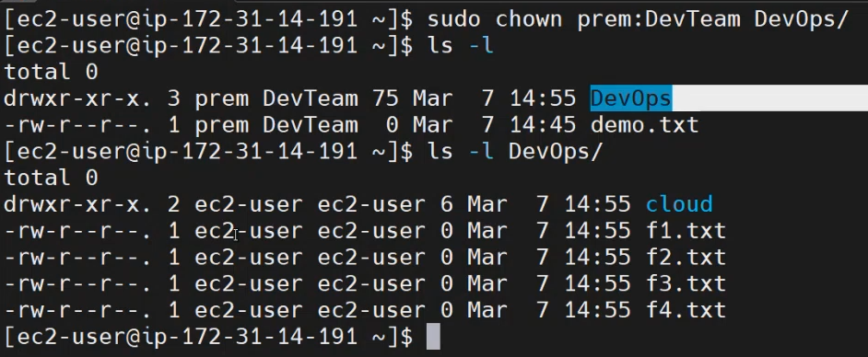

**But it’s possible through this command:**

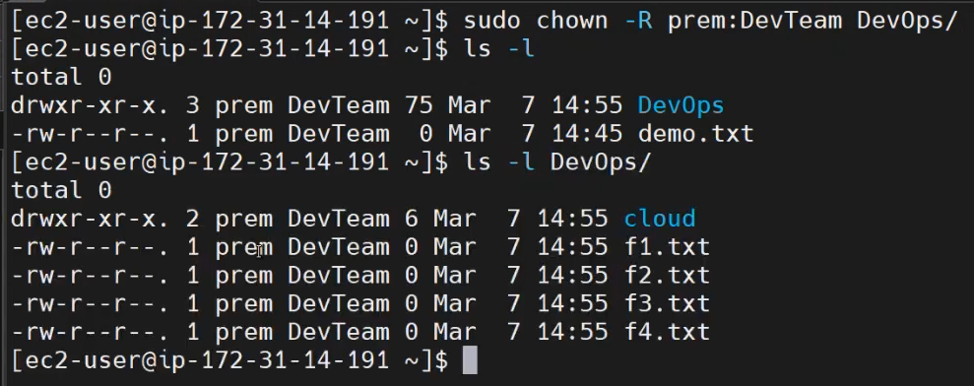

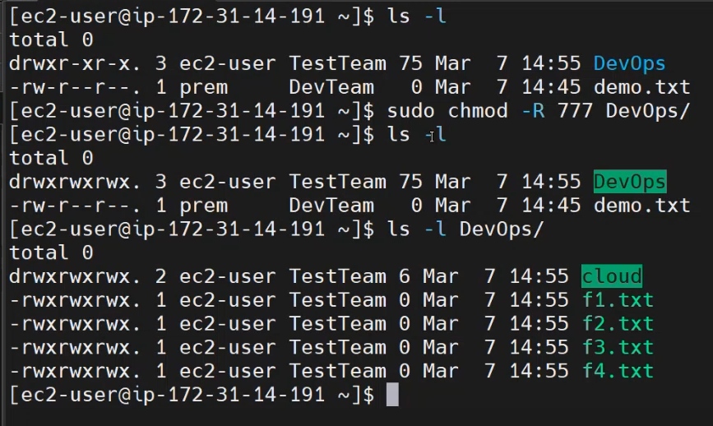

**Package Manager:**

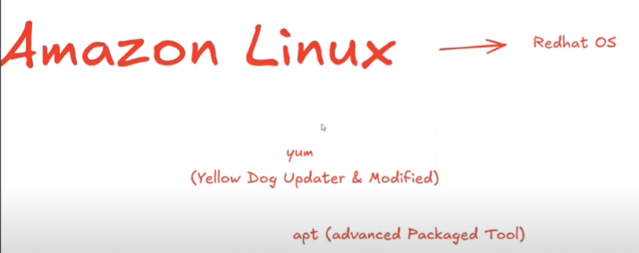

[**https://www.youtube.com/shorts/kDtBLCHGosY**](https://www.youtube.com/shorts/kDtBLCHGosY)

>sudo yum update

>sudo yum install git -y **OR** yes | sudo yum install git

>git –version

>sudo yum remove git -y **OR** yes | sudo yum remove git

**Day 9 - Hard Links vs Soft Links in Linux | How to Create & Use Symbolic and Hard Links Explained**

<https://www.youtube.com/watch?v=WWVp8yT1K4U&list=PL7iDpp0KYTgFhKnHr7X78A8hWFaqOzN6W&index=8>

Understanding hard links and soft links (symbolic links) is essential for efficient Linux file management. In this tutorial, we’ll explore the differences between hard and soft links, how they work, and how to create and manage them effectively. 📌 What You Will Learn: ✅ What are Hard Links? – Understand how hard links reference the same inode and how they affect file storage. ✅ What are Soft Links (Symbolic Links)? – Learn how soft links act as pointers to original files and how they differ from hard links. ✅ Key Differences – Explore the differences between hard and soft links in terms of behavior, limitations, and usage. ✅ How to Create Hard Links – Step-by-step guide using the ln command in Linux. ✅ How to Create Soft Links – Learn how to use the ln -s command to create symbolic links. ✅ Managing and Deleting Links – Best practices for handling, verifying, and removing links. ✅ Common Use Cases – Discover when and why to use hard or soft links in real-world scenarios.

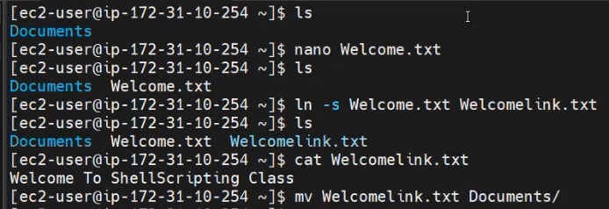

**To Know OS Details:**

**>cat /etc/os-relea**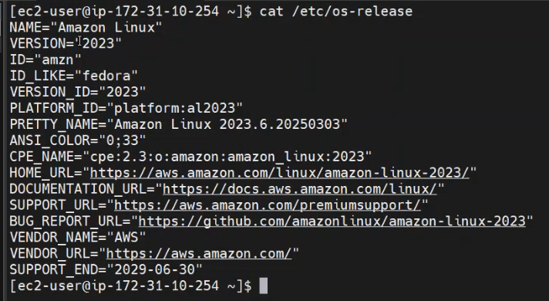

**To Know RAM Space:**

**>free**

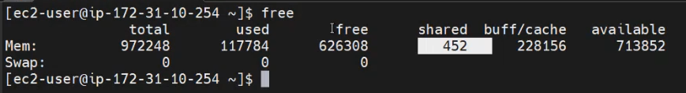

**Soft Link vs Hard Link in Linux**

Linux provides **soft links (symbolic links)** and **hard links** to create references to files. Each has distinct properties and use cases.

**1. Soft Link (Symbolic Link)**

A **soft link (symlink)** is like a shortcut that points to a file or directory.

**Characteristics:**

✔ Can link to files or directories  
✔ Points to the original file's path, not its data  
✔ If the original file is deleted, the soft link becomes **broken** (dangling link)  
✔ Can span across different filesystems

**Syntax:**

bash

CopyEdit

ln -s target_file link_name

**Example:**

bash

CopyEdit

echo "Hello, Linux!" > original.txt # Create a file

ln -s original.txt softlink.txt # Create a symbolic link

ls -l

**Output:**

sql

CopyEdit

lrwxrwxrwx 1 user user 12 Mar 27 10:00 softlink.txt -> original.txt

-rw-r--r-- 1 user user 14 Mar 27 10:00 original.txt

If you delete original.txt:

bash

CopyEdit

rm original.txt

cat softlink.txt

It will return:

yaml

CopyEdit

cat: softlink.txt: No such file or directory

**2. Hard Link**

A **hard link** is a duplicate reference to the same file's **inode**.

**Characteristics:**

✔ Can only link to files (not directories)  
✔ Shares the same **inode number** as the original file  
✔ Even if the original file is deleted, the hard link still contains the data  
✔ Works only within the same filesystem

**Syntax:**

bash

CopyEdit

ln target_file link_name

**Example:**

bash

CopyEdit

echo "Hello, Hard Link!" > original.txt # Create a file

ln original.txt hardlink.txt # Create a hard link

ls -li

**Output (same inode number for both files):**

lua

CopyEdit

1234567 -rw-r--r-- 2 user user 20 Mar 27 10:00 hardlink.txt

1234567 -rw-r--r-- 2 user user 20 Mar 27 10:00 original.txt

Now, delete original.txt:

bash

CopyEdit

rm original.txt

cat hardlink.txt

**Output:**

CopyEdit

Hello, Hard Link!

The hard link still exists and contains the data!

**Key Differences Between Soft and Hard Links**

| **Feature** | **Soft Link (Symbolic Link)** | **Hard Link** |
| --- | --- | --- |
| Points To | File/directory path | Same inode (file data) |
| Works Across Filesystems? | ✅ Yes | ❌ No |
| Works for Directories? | ✅ Yes (with -s) | ❌ No |
| If Original File is Deleted? | ❌ Link breaks (dangling) | ✅ Data is still accessible |
| Uses the Same Inode? | ❌ No | ✅ Yes |

**When to Use?**

* **Soft links** → Use when you need shortcuts, work across filesystems, or reference directories
* **Hard links** → Use when you need backup copies that persist even if the original is deleted

**Day 10 - Essential Linux Networking Commands: ping, ifconfig, wget, and curl Explained**

<https://www.youtube.com/watch?v=FpySl1zV5M8&list=PL7iDpp0KYTgFhKnHr7X78A8hWFaqOzN6W&index=9&t=4s>

Networking:

>ifconfig // To know private ip address

>ping [www.gooogle.com](http://www.gooogle.com) // ICMP should be enabled under security, you will get response when we use ping command for the website.

>wget URL // To download anything

>curl URL // To display page source code

**Day 11 - Configure Sudoers in Linux: Manage Sudo Permissions,User Access,&Root Privileges Explained!**

<https://www.youtube.com/watch?v=3uWVDsT3GyU&list=PL7iDpp0KYTgFhKnHr7X78A8hWFaqOzN6W&index=10>

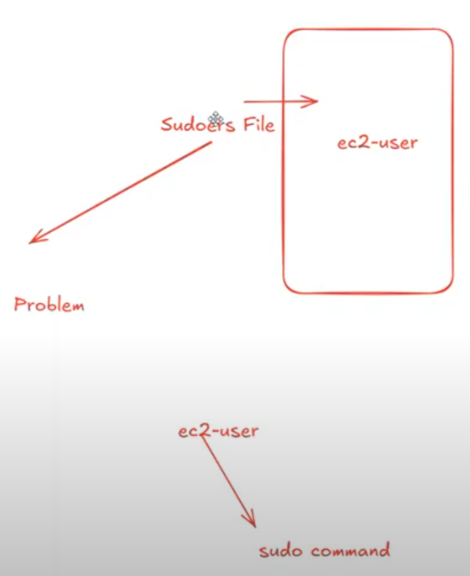

root>cat /etc/sudoers

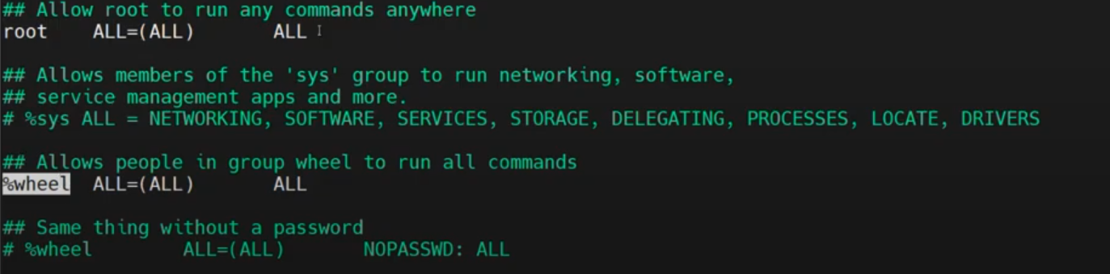

root>lid -g wheel

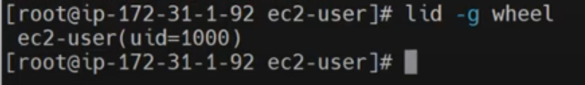

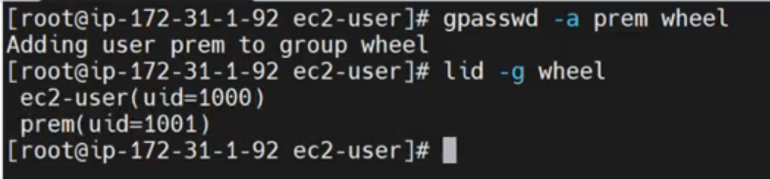

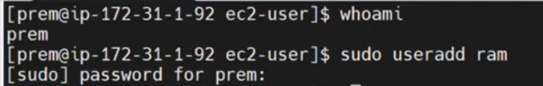

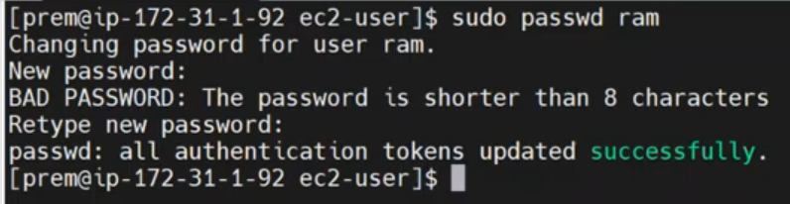

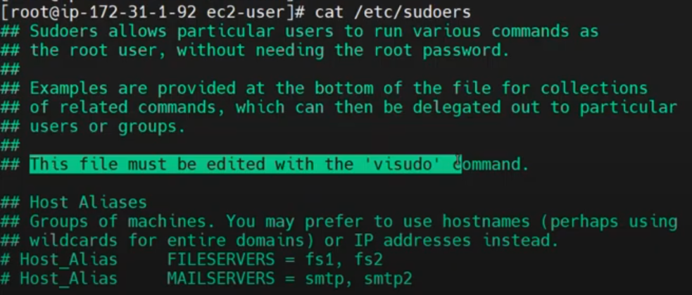

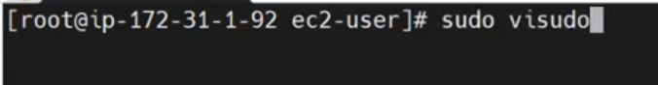

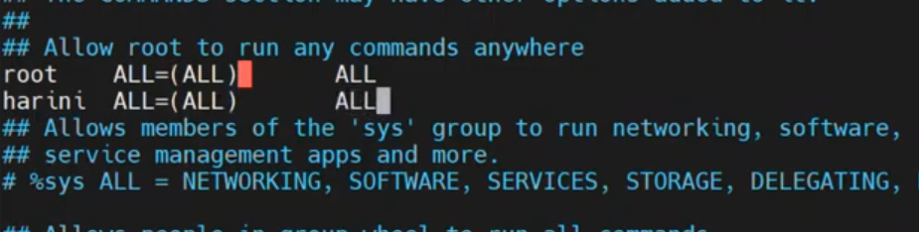

If you don’t want to ask password for harini user, while install, etc

**What is the sudoers File in Linux?**

The sudoers file is a configuration file in Unix-like operating systems that controls which users can execute commands as other users (usually as root) using the sudo command. It is typically located at /etc/sudoers and should only be edited using the visudo command to prevent syntax errors [[1](https://www.linuxfoundation.org/blog/blog/classic-sysadmin-configuring-the-linux-sudoers-file)].

**Importance of the sudoers File:**

1. **Enhanced Security** – Prevents unauthorized users from executing administrative commands.
2. **Least Privilege Principle** – Allows users to run only specific commands with elevated privileges.
3. **Auditability** – Logs every sudo command execution for security tracking.
4. **Flexibility** – Provides granular control over user permissions.

**Examples of sudoers Configuration:**

1. **Grant a User Full Root Privileges**:

username ALL=(ALL) ALL

This allows username to run any command as any user.

1. **Allow a User to Run Specific Commands**:

username ALL=(ALL) NOPASSWD: /usr/bin/apt-get, /usr/bin/systemctl restart apache2

This allows username to run apt-get and restart Apache without entering a password.

1. **Grant Group-Level Permissions**:

%developers ALL=(ALL) ALL

This allows all users in the developers group to run any command as root.

1. **Restrict Root Access to Certain Hosts**:

username server1=(ALL) ALL

This limits username to execute sudo only on server1.

By properly configuring sudoers, administrators can maintain a secure and well-controlled Linux environment [[2](https://heshandharmasena.medium.com/explain-sudoers-file-configuration-in-linux-1fe00f4d6159)].

**🌐 Sources**

1. [Classic SysAdmin: Configuring the Linux Sudoers File](https://www.linuxfoundation.org/blog/blog/classic-sysadmin-configuring-the-linux-sudoers-file)
2. [Explain Sudoers File Configuration in Linux](https://heshandharmasena.medium.com/explain-sudoers-file-configuration-in-linux-1fe00f4d6159)
3. [Useful Sudoers Configurations for Linux](https://www.geeksforgeeks.org/useful-sudoers-configurations-for-setting-sudo-in-linux/)

**Day 12 - Mastering Linux Commands: whereis, find, and top Explained!**

<https://www.youtube.com/watch?v=H7aw0JMVsZk&list=PL7iDpp0KYTgFhKnHr7X78A8hWFaqOzN6W&index=11>

>whereis git // To know the path of the software

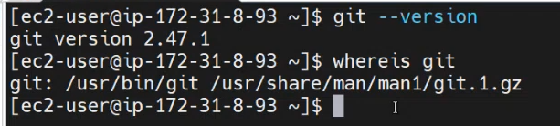

>find -name redhat.txt // To know the path of the file/directory

